Libelium Station Configuration

The first step is to connect the Libelium Smart Environment PRO with the appropriate sensors and via usb with the laptop.  
On the device, we downloaded the Waspmode IDE which is the environment where we program and upload the code for the libelium station to collect and print the data collected.

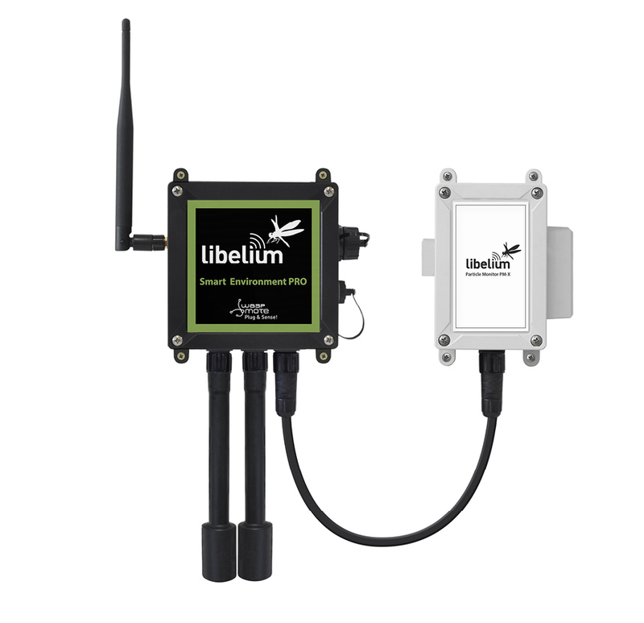

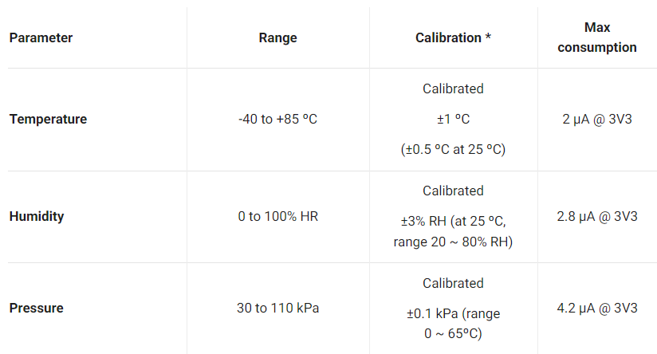

These are the values of the parameters in order to have a general idea about the usual measured values.

